PROJECT REPORT

SOFTWARE ENGINEERING (IS F341)

AN ANDROID APPLICATION FOR INTERNSHIPS AND COLLEGE EVENTS



BIRLA INSTITUTE OF TECHNOLOGY AND SCIENCES

PILANI, HYDERABAD CAMPUS

ILLENDULA MANIDEEP (2011C6PS662H)

GAURAV SUMANTH ABBURI (2011C6PS570H)

**Introduction**

The project aims at developing a mobile application for android users, to view the various internships available in the industry. It also features postings of college events currently happening.

The user has to register, giving his details – his personal details, his area of interest, etc. Internships can also be posted by the users, which will be viewed by other users. In the same way, college events can also be posted and viewed.

The internships and college events will be filtered according to the area of interest specified by the user during registration.

**SCOPE**

This mobile app will help **STUDENTS** in finding internships specific to their area of interest. Students can also publicise their start-ups.

It will also be like an events calendar where students can view the various events being conducted in different colleges or organisations. So one can know about technical workshops, competitions, cultural events, etc.

**Future Scope:**

Having installed the App on their mobiles, the students will be able to view all internships and college events in their mobile itself. No time will be wasted in surfing the internet.

**Use Case Diagram**

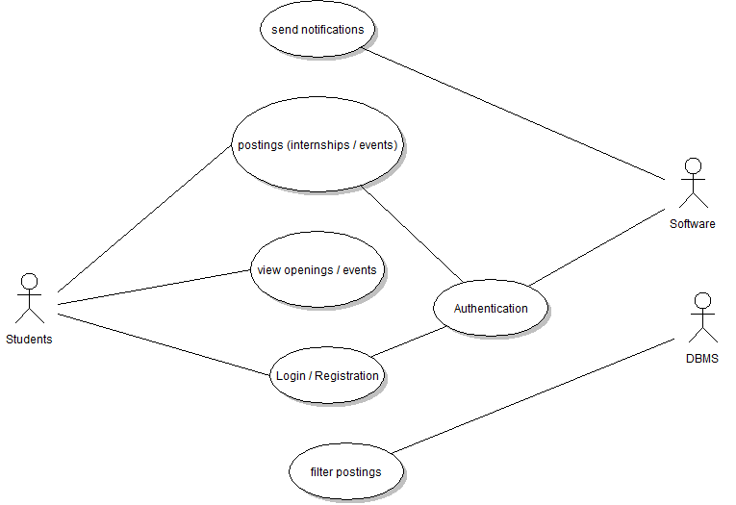

**Class Diagram**

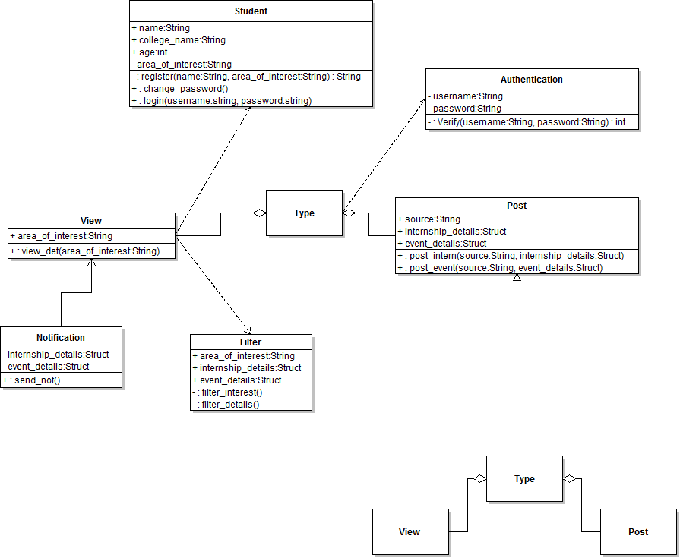

**DATA FLOW DIAGRAMS**

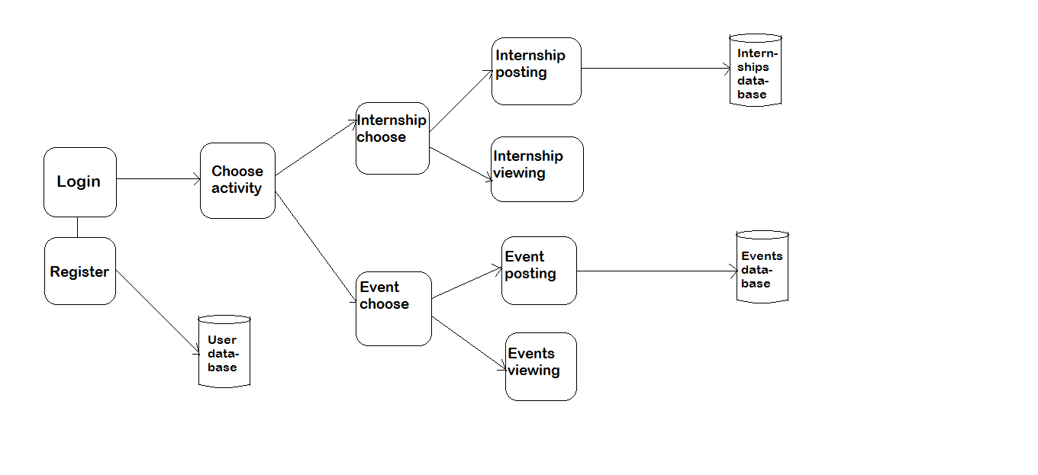

**Technologies used**

* Eclipse (Android)– for the GUI and Database connections.
* SQL – for implementing the filters on displaying the postings.
* Stackmob API –

For implementing the databases. The databases are stored online (cloud).

Server side implementation.

[www.stackmob.com](http://www.stackmob.com)

**Coding**

1. **Login Page:**

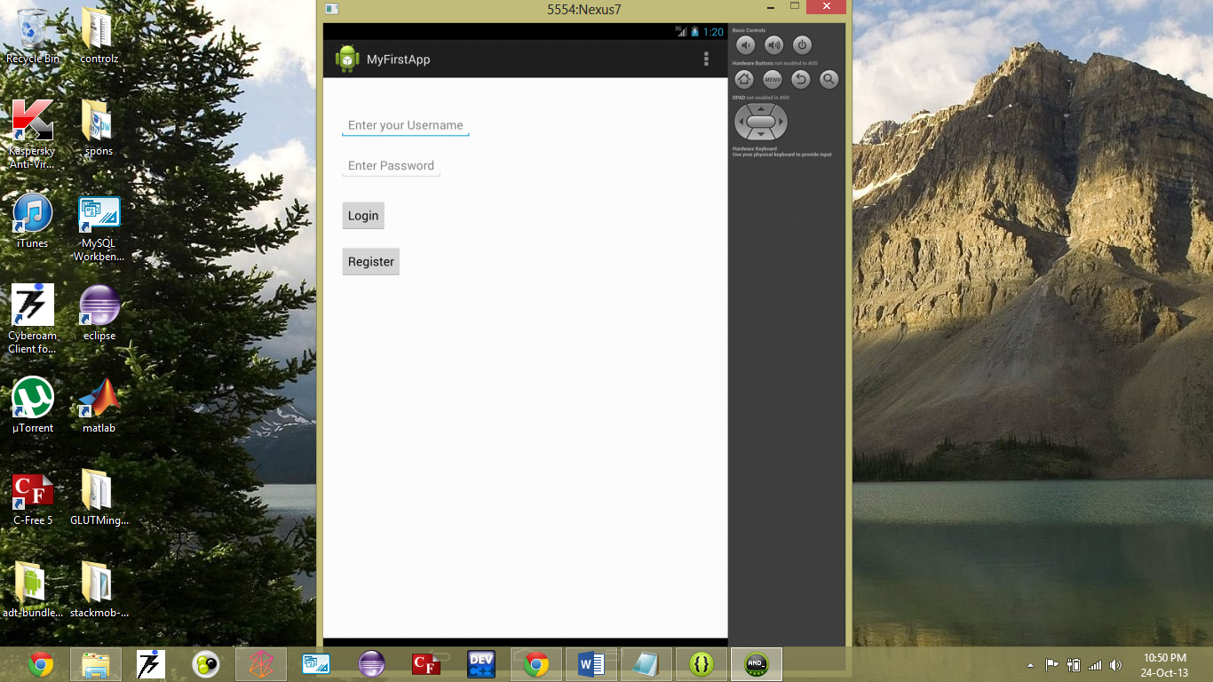

**package** com.example.myfirstapp;

**import** com.stackmob.android.sdk.common.StackMobAndroid;

**import** com.stackmob.sdk.callback.StackMobModelCallback;

**import** com.stackmob.sdk.exception.StackMobException;

**import** android.os.Bundle;

**import** android.view.Gravity;

**import** android.view.View;

**import** android.app.Activity;

**import** android.view.Menu;

**import** android.widget.EditText;

**import** android.widget.Toast;

**import** android.content.*;

**public** **class** MainActivity **extends** Activity {

**public** **final** **static** String *EXTRA_MESSAGE* = "com.example.myfirstapp.MESSAGE";

@Override

**protected** **void** onCreate(Bundle savedInstanceState) {

**super**.onCreate(savedInstanceState);

setContentView(R.layout.*activity_main*);

StackMobAndroid.*init*(getApplicationContext(), 0, "a1748a0f-8364-4205-bb16-271436d8a481");

}

@Override

**public** **boolean** onCreateOptionsMenu(Menu menu) {

// Inflate the menu; this adds items to the action bar if it is present.

getMenuInflater().inflate(R.menu.*main*, menu);

**return** **true**;

}

/** Called when the user clicks the Send button */

**public** **void** register(View view){

Intent reg_int = **new** Intent(**this**, RegisterActivity.**class**);

startActivity(reg_int);

}

**public** **void** login(View view){

**try**{

EditText username = (EditText) findViewById(R.id.*username*);

String u = username.getText().toString();

EditText password = (EditText) findViewById(R.id.*pass_word*);

String p = password.getText().toString();

UserDetails user=**new** UserDetails(u,p);

user.login(**new** StackMobModelCallback() {

@Override

**public** **void** success() {

Intent log_int = **new** Intent(getBaseContext(), ChooseActivity.**class**);

startActivity(log_int);

}

@Override

**public** **void** failure(StackMobException arg0) {

// **TODO** Auto-generated method stub

**final** Context context = getApplicationContext();

**final** CharSequence text = "Invalid Username and Password";

**final** **int** duration = Toast.*LENGTH_LONG*;

runOnUiThread(**new** Runnable() {

**public** **void** run() {

Toast toast = Toast.*makeText*(context, text, duration);

toast.setGravity(Gravity.*BOTTOM*|Gravity.*LEFT*, 0, 0);

toast.show();

}

});

}

});

}**catch**(Exception e)

{

System.*out*.println(e.getMessage().toString());

}

}

}

/**public void sendMessage(View view) {

Intent intent = new Intent(this, DisplayMessageActivity.class);

EditText editText = (EditText) findViewById(R.id.edit_message);

String message = editText.getText().toString();

intent.putExtra(EXTRA_MESSAGE, message);

startActivity(intent);*/

**( XML Code )**

<LinearLayout xmlns:android=*"http://schemas.android.com/apk/res/android"*

xmlns:tools=*"http://schemas.android.com/tools"*

android:layout_width=*"match_parent"*

android:layout_height=*"wrap_content"*

android:orientation=*"vertical"* >

<EditText

android:id=*"@+id/username"*

android:layout_width=*"wrap_content"*

android:layout_height=*"wrap_content"*

android:layout_marginLeft=*"25dp"*

android:layout_marginTop=*"50dp"*

android:hint=*"@string/username"* />

<EditText

android:id=*"@+id/pass_word"*

android:layout_width=*"wrap_content"*

android:layout_height=*"wrap_content"*

android:layout_marginLeft=*"25dp"*

android:layout_marginTop=*"20dp"*

android:hint=*"@string/pass_word"* />

<Button

android:layout_width=*"wrap_content"*

android:layout_height=*"wrap_content"*

android:layout_marginLeft=*"25dp"*

android:layout_marginTop=*"30dp"*

android:onClick=*"login"*

android:text=*"@string/button_login"* />

<Button

android:layout_width=*"wrap_content"*

android:layout_height=*"wrap_content"*

android:layout_marginLeft=*"25dp"*

android:layout_marginTop=*"20dp"*

android:onClick=*"register"*

android:text=*"@string/button_register"* />

<!--<Button

android:layout_width="wrap_content"

android:layout_height="wrap_content"

android:text="@string/button_send"

android:onClick="sendMessage" />-->

</LinearLayout>

2.**Register Page**

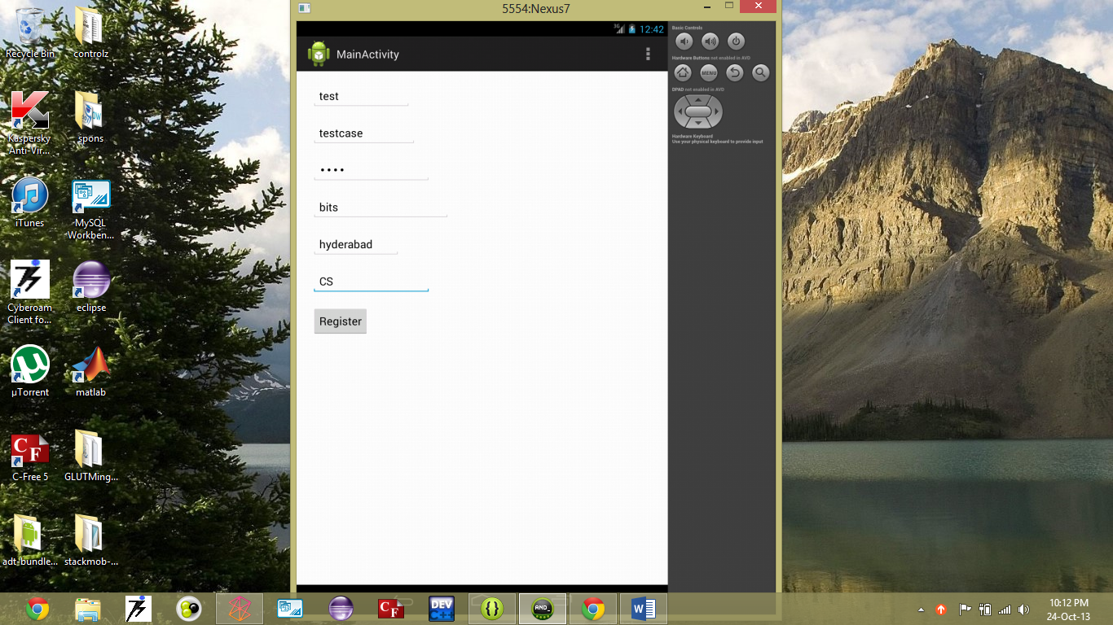

package com.example.myfirstapp;

import android.os.Bundle;

import android.app.Activity;

import android.content.Intent;

import android.view.Menu;

import android.view.View;

import android.widget.EditText;

public class RegisterActivity extends Activity {

@Override

protected void onCreate(Bundle savedInstanceState) {

super.onCreate(savedInstanceState);

setContentView(R.layout.activity_register);

}

@Override

public boolean onCreateOptionsMenu(Menu menu) {

// Inflate the menu; this adds items to the action bar if it is present.

getMenuInflater().inflate(R.menu.register, menu);

return true;

}

public void reg_done(View view){

try {

EditText name = (EditText) findViewById(R.id.reg_name);

String n = name.getText().toString();

EditText user = (EditText) findViewById(R.id.reg_username);

String u = user.getText().toString();

EditText password = (EditText) findViewById(R.id.reg_password);

String p = password.getText().toString();

EditText college = (EditText) findViewById(R.id.reg_college);

String c = college.getText().toString();

EditText city = (EditText) findViewById(R.id.reg_city);

String d = city.getText().toString();

EditText interest = (EditText) findViewById(R.id.reg_interest);

String i = interest.getText().toString();

UserDetails userdetails=new UserDetails(n,u,p,c,d,i);

userdetails.save();

Intent reg_done = new Intent(this, MainActivity.class);

startActivity(reg_done);

}

catch(Exception e) {

System.out.println(e.getMessage().toString());

}

}

}

**( XML Code )**

<LinearLayout xmlns:android=*"http://schemas.android.com/apk/res/android"*

xmlns:tools=*"http://schemas.android.com/tools"*

android:layout_width=*"match_parent"*

android:layout_height=*"match_parent"*

android:orientation=*"vertical"* >

<EditText

android:id=*"@+id/reg_name"*

android:layout_width=*"wrap_content"*

android:layout_height=*"wrap_content"*

android:layout_marginLeft=*"25dp"*

android:layout_marginTop=*"20dp"*

android:hint=*"@string/reg_name"* />

<EditText

android:id=*"@+id/reg_username"*

android:layout_width=*"wrap_content"*

android:layout_height=*"wrap_content"*

android:layout_marginLeft=*"25dp"*

android:layout_marginTop=*"20dp"*

android:hint=*"@string/reg_username"* />

<EditText

android:id=*"@+id/reg_password"*

android:layout_width=*"wrap_content"*

android:layout_height=*"wrap_content"*

android:layout_marginLeft=*"25dp"*

android:layout_marginTop=*"20dp"*

android:hint=*"@string/reg_password"*

android:inputType=*"textPassword"* />

<EditText

android:id=*"@+id/reg_college"*

android:layout_width=*"wrap_content"*

android:layout_height=*"wrap_content"*

android:layout_marginLeft=*"25dp"*

android:layout_marginTop=*"20dp"*

android:hint=*"@string/reg_college"* />

<EditText

android:id=*"@+id/reg_city"*

android:layout_width=*"wrap_content"*

android:layout_height=*"wrap_content"*

android:layout_marginLeft=*"25dp"*

android:layout_marginTop=*"20dp"*

android:hint=*"@string/reg_city"* />

<EditText

android:id=*"@+id/reg_interest"*

android:layout_width=*"wrap_content"*

android:layout_height=*"wrap_content"*

android:layout_marginLeft=*"25dp"*

android:layout_marginTop=*"20dp"*

android:hint=*"@string/reg_interest"* />

<Button

android:layout_width=*"wrap_content"*

android:layout_height=*"wrap_content"*

android:layout_marginLeft=*"25dp"*

android:layout_marginTop=*"20dp"*

android:onClick=*"reg_done"*

android:text=*"@string/button_reg_done"* />

</LinearLayout>

**Stackmob database table for UserDetails**

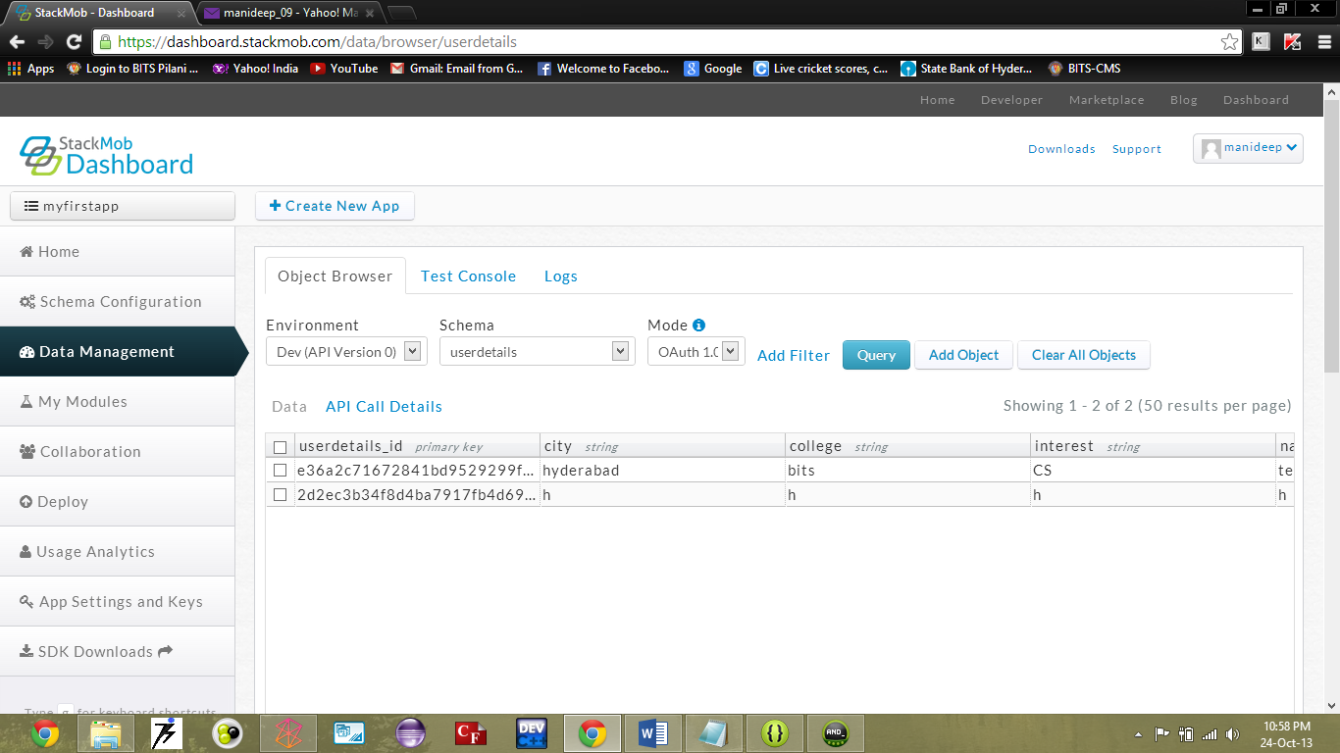

**package** com.example.myfirstapp;

**import** com.stackmob.sdk.model.StackMobModel;

**public** **class** UserDetails **extends** StackMobModel{

**public** String name;

**public** String username;

**public** String password;

**public** String college;

**public** String city;

**public** String interest;

**public** UserDetails(String name,String username,String password,String college,String city,String interest){

**super**(UserDetails.**class**);

**this**.name=name;

**this**.username=username;

**this**.password=password;

**this**.college=college;

**this**.city=city;

**this**.interest=interest;

}

**public** String getName() {

**return** name;

}

**public** **void** setName(String name) {

**this**.name = name;

}

**public** String getUsername() {

**return** username;

}

**public** **void** setUsername(String username) {

**this**.username = username;

}

**public** String getPassword() {

**return** password;

}

**public** **void** setPassword(String password) {

**this**.password = password;

}

**public** String getCollege() {

**return** college;

}

**public** **void** setCollege(String college) {

**this**.college = college;

}

**public** String getCity() {

**return** city;

}

**public** **void** setCity(String city) {

**this**.city = city;

}

**public** String getInterest() {

**return** interest;

}

**public** **void** setInterest(String interest) {

**this**.interest = interest;

}

}

3. **After Registration ( Login )**

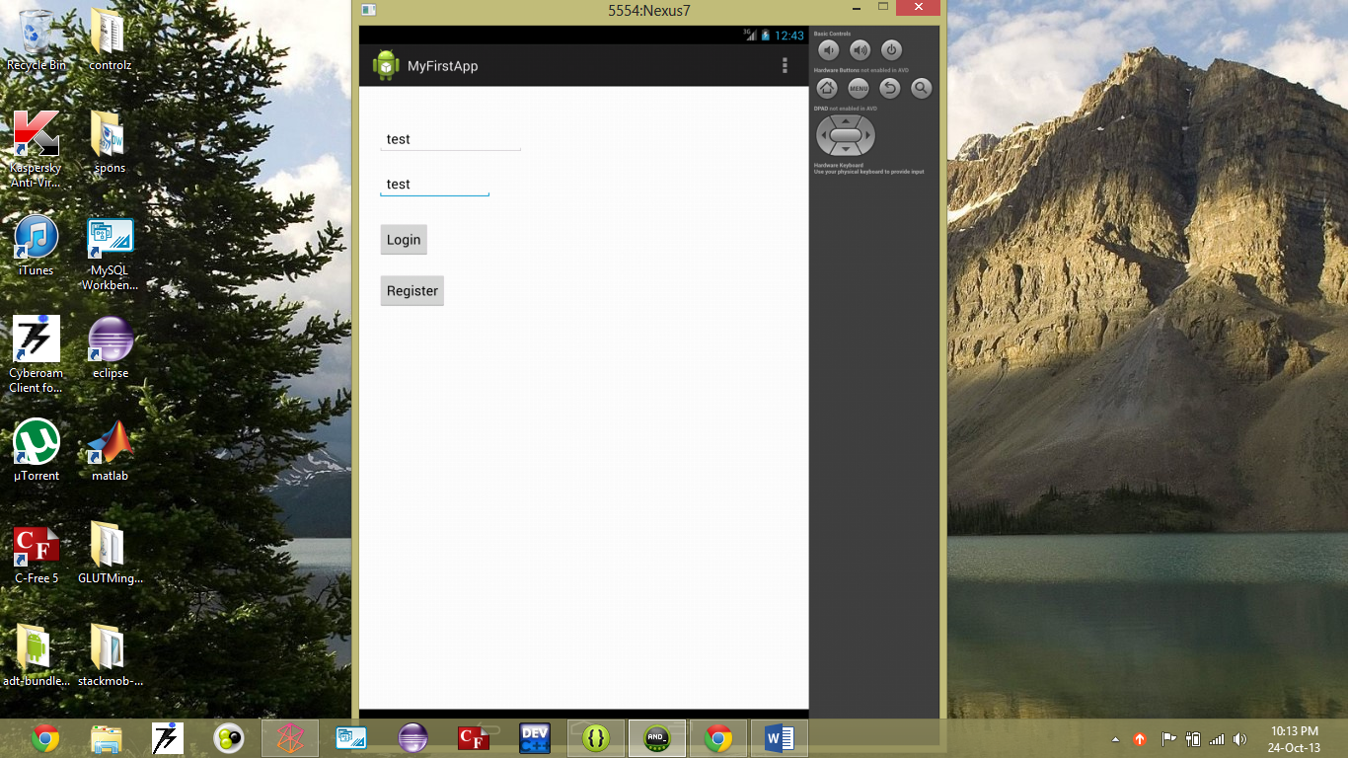

4. **Choosing between internships and events**

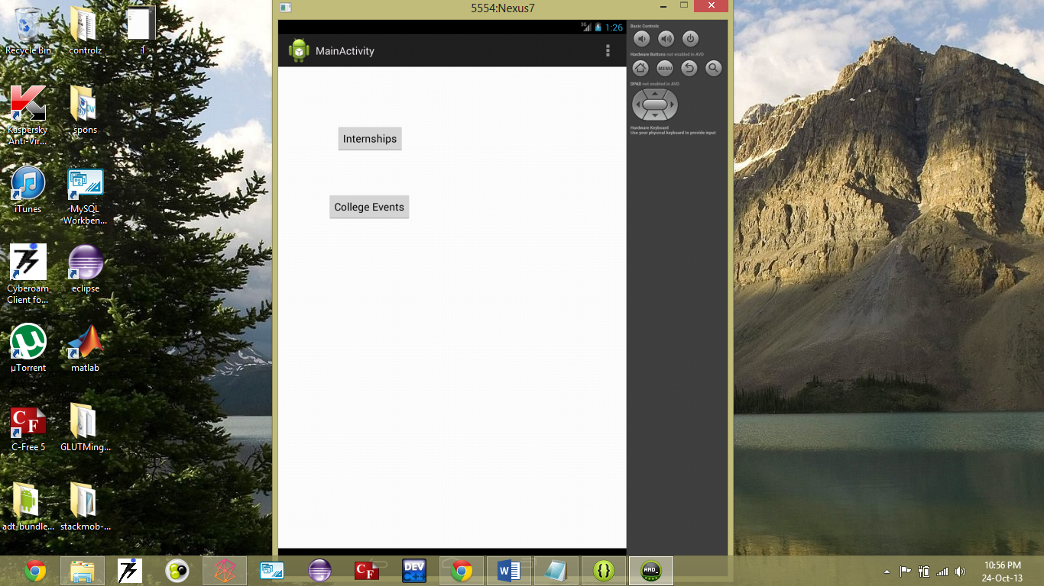

package com.example.myfirstapp;

import android.os.Bundle;

import android.content.*;

import android.view.*;

import android.app.Activity;

import android.view.Menu;

public class ChooseActivity extends Activity {

@Override

protected void onCreate(Bundle savedInstanceState) {

super.onCreate(savedInstanceState);

setContentView(R.layout.activity_choose);

}

@Override

public boolean onCreateOptionsMenu(Menu menu) {

// Inflate the menu; this adds items to the action bar if it is present.

getMenuInflater().inflate(R.menu.choose, menu);

return true;

}

public void choose_intern(View view) {

Intent cho_intern = new Intent(this, InternchooseActivity.class);

startActivity(cho_intern);

}

public void choose_event(View view) {

Intent cho_event = new Intent(this, ColchooseActivity.class);

startActivity(cho_event);

}

}

**( XML Code )**

<LinearLayout xmlns:android=*"http://schemas.android.com/apk/res/android"*

xmlns:tools=*"http://schemas.android.com/tools"*

android:layout_width=*"match_parent"*

android:layout_height=*"match_parent"*

android:orientation=*"vertical"* >

<Button

android:layout_width=*"wrap_content"*

android:layout_height=*"wrap_content"*

android:layout_marginLeft=*"100dp"*

android:layout_marginTop=*"100dp"*

android:onClick=*"choose_intern"*

android:text=*"@string/button_intern"* />

<Button

android:layout_width=*"wrap_content"*

android:layout_height=*"wrap_content"*

android:layout_marginLeft=*"85dp"*

android:layout_marginTop=*"70dp"*

android:onClick=*"choose_event"*

android:text=*"@string/button_event"* />

</LinearLayout>

**5. Choosing between posting and viewing internships**

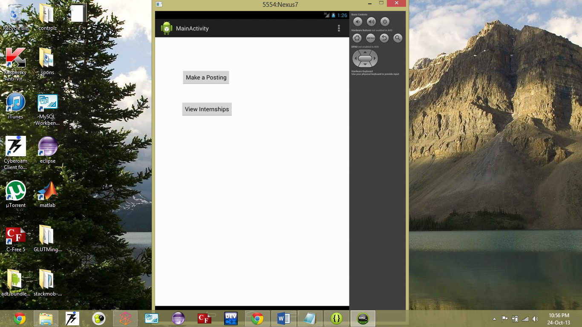

package com.example.myfirstapp;

import android.os.Bundle;

import android.app.Activity;

import android.content.Intent;

import android.view.Menu;

import android.view.View;

public class InternchooseActivity extends Activity {

@Override

protected void onCreate(Bundle savedInstanceState) {

super.onCreate(savedInstanceState);

setContentView(R.layout.activity_internchoose);

}

@Override

public boolean onCreateOptionsMenu(Menu menu) {

// Inflate the menu; this adds items to the action bar if it is present.

getMenuInflater().inflate(R.menu.internchoose, menu);

return true;

}

public void intern_post(View view){

Intent reg_int = new Intent(this, InternpostActivity.class);

startActivity(reg_int);

}

}

**( XML Code )**

<LinearLayout xmlns:android=*"http://schemas.android.com/apk/res/android"*

xmlns:tools=*"http://schemas.android.com/tools"*

android:layout_width=*"match_parent"*

android:layout_height=*"match_parent"*

android:orientation=*"vertical"* >

<Button

android:layout_width=*"wrap_content"*

android:layout_height=*"wrap_content"*

android:layout_marginLeft=*"83dp"*

android:layout_marginTop=*"100dp"*

android:onClick=*"intern_post"*

android:text=*"@string/button_intern_post"* />

<Button

android:layout_width=*"wrap_content"*

android:layout_height=*"wrap_content"*

android:layout_marginLeft=*"80dp"*

android:layout_marginTop=*"50dp"*

android:onClick=*"intern_view"*

android:text=*"@string/button_intern_view"* />

</LinearLayout>

**6. Post internship**

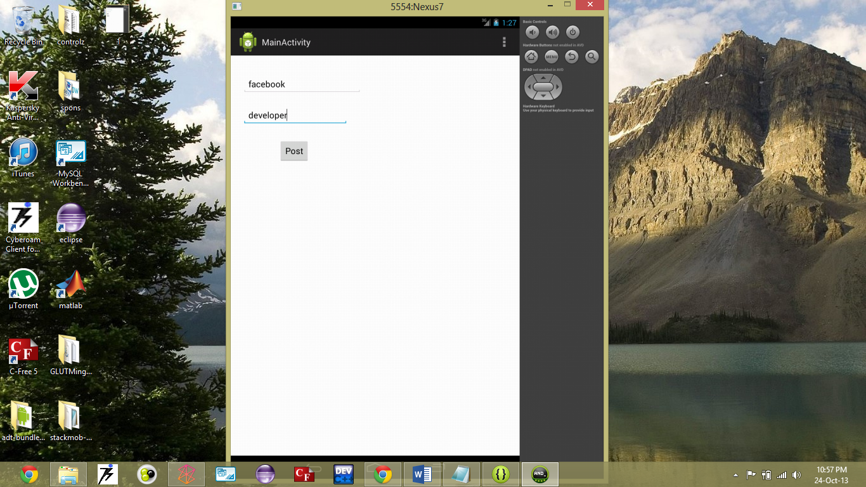

package com.example.myfirstapp;

import android.os.Bundle;

import android.app.Activity;

import android.content.Intent;

import android.view.Menu;

import android.view.View;

import android.widget.EditText;

public class InternpostActivity extends Activity {

@Override

protected void onCreate(Bundle savedInstanceState) {

super.onCreate(savedInstanceState);

setContentView(R.layout.activity_internpost);

}

@Override

public boolean onCreateOptionsMenu(Menu menu) {

// Inflate the menu; this adds items to the action bar if it is present.

getMenuInflater().inflate(R.menu.internpost, menu);

return true;

}

public void intern_post(View view){

EditText org = (EditText) findViewById(R.id.intpost_org);

String o = org.getText().toString();

EditText scope = (EditText) findViewById(R.id.intpost_scope);

String s = scope.getText().toString();

InternPost internpost = new InternPost(o,s);

internpost.save();

Intent intern_post = new Intent(this, InternchooseActivity.class);

startActivity(intern_post);

}

}

**( XML Code )**

<LinearLayout xmlns:android=*"http://schemas.android.com/apk/res/android"*

xmlns:tools=*"http://schemas.android.com/tools"*

android:layout_width=*"match_parent"*

android:layout_height=*"match_parent"*

android:orientation=*"vertical"* >

<EditText

android:id=*"@+id/intpost_org"*

android:layout_width=*"wrap_content"*

android:layout_height=*"wrap_content"*

android:layout_gravity=*"top"*

android:layout_marginLeft=*"25dp"*

android:layout_marginTop=*"40dp"*

android:hint=*"@string/intpost_org"* />

<EditText

android:id=*"@+id/intpost_scope"*

android:layout_width=*"wrap_content"*

android:layout_height=*"wrap_content"*

android:layout_marginLeft=*"25dp"*

android:layout_marginTop=*"25dp"*

android:hint=*"@string/intpost_scope"* />

<Button

android:layout_width=*"wrap_content"*

android:layout_height=*"wrap_content"*

android:layout_marginLeft=*"100dp"*

android:layout_marginTop=*"30dp"*

android:onClick=*"intern_post"*

android:text=*"@string/button_intpost"* />

</LinearLayout>

**Stackmob database table for intern postings**

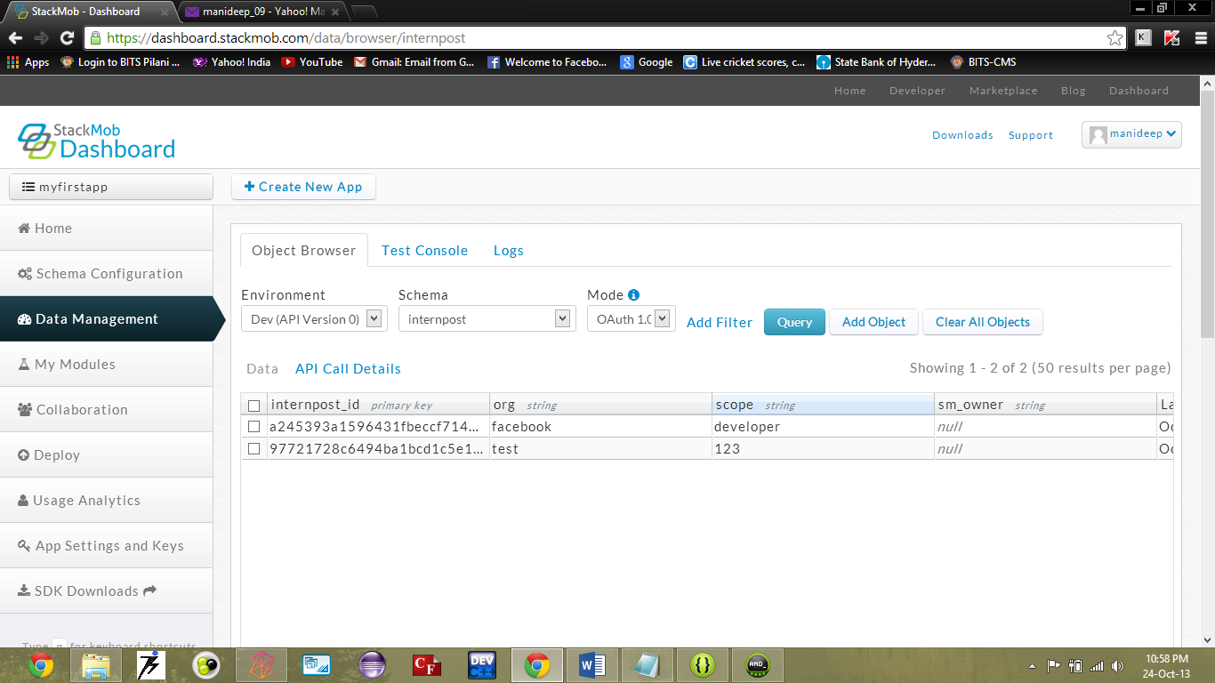

**package** com.example.myfirstapp;

**import** com.stackmob.sdk.model.StackMobModel;

**public** **class** InternPost **extends** StackMobModel {

**public** String org;

**public** String scope;

**public** InternPost(String org,String scope){

**super**(InternPost.**class**);

**this**.org=org;

**this**.scope=scope;

}

**public** String getOrg() {

**return** org;

}

**public** **void** setOrg(String org) {

**this**.org = org;

}

**public** String getScope() {

**return** scope;

}

**public** **void** setScope(String scope) {

**this**.scope = scope;

}

}

7. **After Posting internship:**

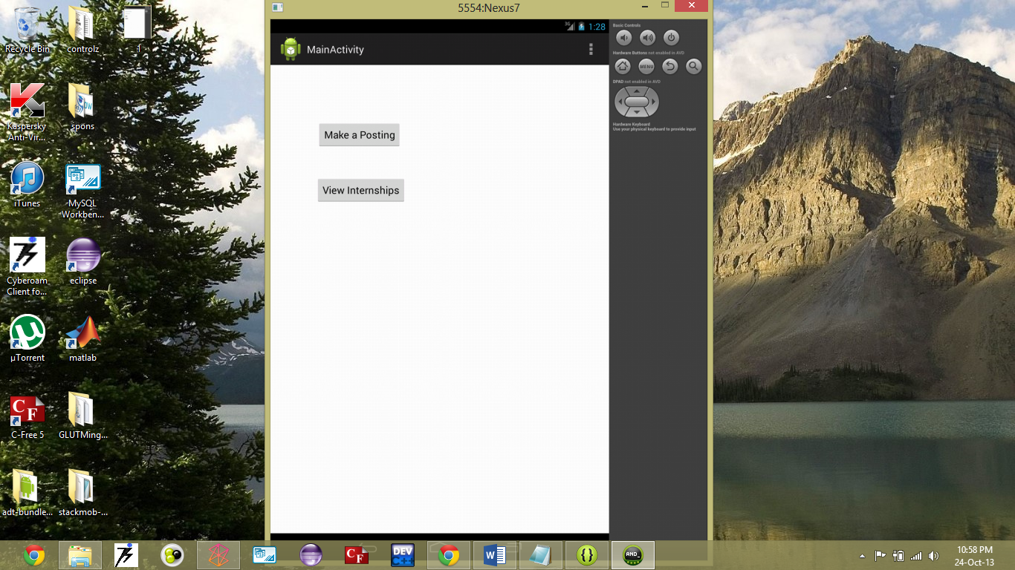

**Viewing Internships**

**package** com.example.myfirstapp;

**import** java.util.Arrays;

**import** java.util.List;

**import** com.stackmob.sdk.api.StackMobOptions;

**import** com.stackmob.sdk.api.StackMobQuery;

**import** com.stackmob.sdk.callback.StackMobQueryCallback;

**import** com.stackmob.sdk.exception.StackMobException;

**import** android.os.Bundle;

**import** android.os.CountDownTimer;

**import** android.view.Gravity;

**import** android.widget.Toast;

**import** android.app.Activity;

**import** android.content.Context;

**public** **class** DisplayMessage2 **extends** Activity {

StringBuilder st = **new** StringBuilder();

@Override

**public** **void** onCreate(Bundle savedInstanceState) {

**super**.onCreate(savedInstanceState);

EventPost.*query*(InternPost.**class**, **new** StackMobQuery().isInRange(0, 9),

StackMobOptions.*selectedFields*(Arrays.*asList*("org", "scope")),

**new** StackMobQueryCallback<InternPost>() {

**public** **void** success(**final** List<InternPost> result) {

// You've now got a list of the tasks

**final** Context context = getApplicationContext();

**final** **int** duration = Toast.*LENGTH_LONG*;

**for**(InternPost e : result){

st.append(e.toString());

}

**final** CharSequence text = st;

runOnUiThread(**new** Runnable() {

**public** **void** run() {

**final** Toast t = Toast.*makeText*(context, text, duration);

t.setGravity(Gravity.*TOP*|Gravity.*LEFT*, 0, 0);

t.show();

**new** CountDownTimer(20000, 1000)

{

**public** **void** onTick(**long** millisUntilFinished) {t.show();}

**public** **void** onFinish() {t.show();}

}.start();

}

});

}

**public** **void** failure(StackMobException e) {

}

});

}

}

8. **Choosing between posting events and viewing events**

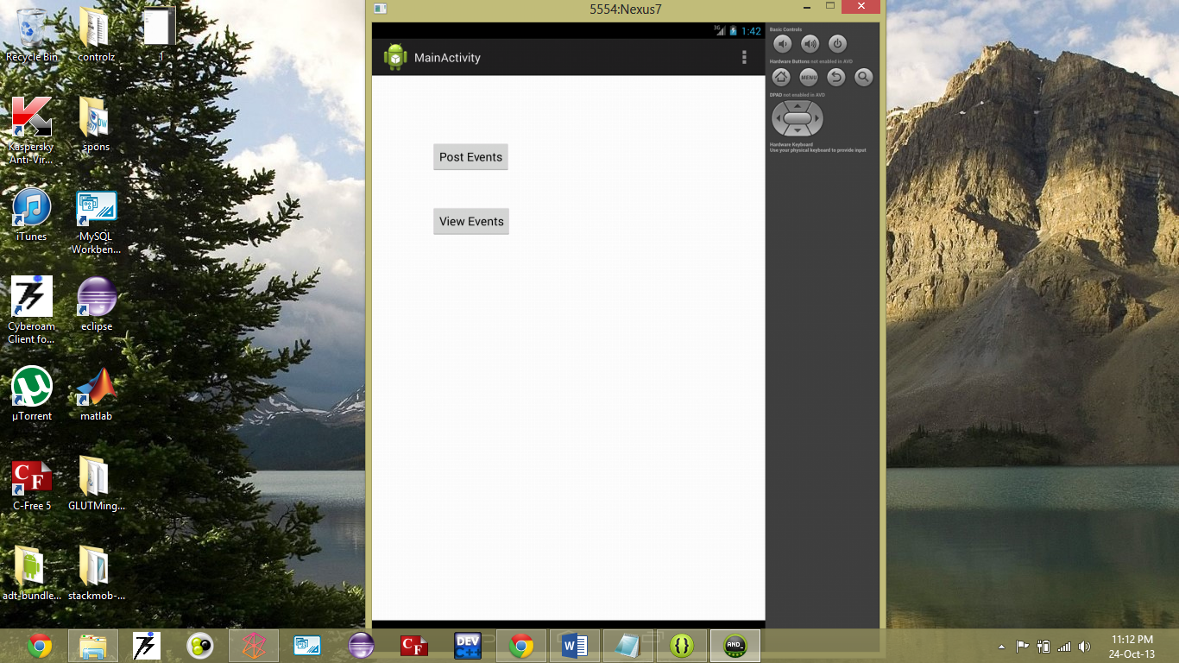

package com.example.myfirstapp;

import android.os.Bundle;

import android.app.Activity;

import android.content.Intent;

import android.view.Menu;

import android.view.View;

public class ColchooseActivity extends Activity {

@Override

protected void onCreate(Bundle savedInstanceState) {

super.onCreate(savedInstanceState);

setContentView(R.layout.activity_colchoose);

}

@Override

public boolean onCreateOptionsMenu(Menu menu) {

// Inflate the menu; this adds items to the action bar if it is present.

getMenuInflater().inflate(R.menu.colchoose, menu);

return true;

}

public void event_post(View view){

Intent event_int = new Intent(this, ColpostActivity.class);

startActivity(event_int);

}

}

**( XML Code )**

<LinearLayout xmlns:android=*"http://schemas.android.com/apk/res/android"*

xmlns:tools=*"http://schemas.android.com/tools"*

android:layout_width=*"match_parent"*

android:layout_height=*"match_parent"*

android:orientation=*"vertical"* >

<Button

android:layout_width=*"wrap_content"*

android:layout_height=*"wrap_content"*

android:layout_marginLeft=*"90dp"*

android:layout_marginTop=*"100dp"*

android:onClick=*"event_post"*

android:text=*"@string/button_event_post"* />

<Button

android:layout_width=*"wrap_content"*

android:layout_height=*"wrap_content"*

android:layout_marginLeft=*"90dp"*

android:layout_marginTop=*"50dp"*

android:onClick=*"event_view"*

android:text=*"@string/button_event_view"* />

</LinearLayout>

9. **Event posting**

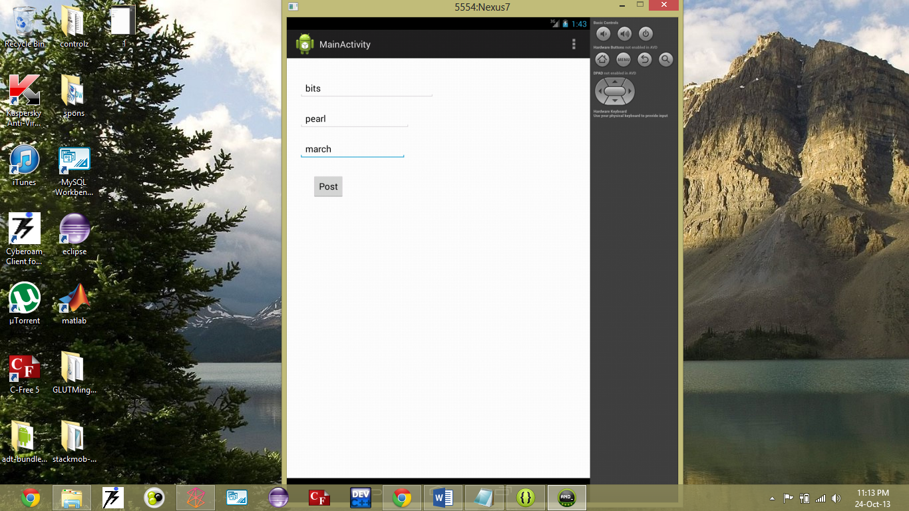

package com.example.myfirstapp;

import android.os.Bundle;

import android.app.Activity;

import android.content.Intent;

import android.view.Menu;

import android.view.View;

import android.widget.EditText;

public class ColpostActivity extends Activity {

@Override

protected void onCreate(Bundle savedInstanceState) {

super.onCreate(savedInstanceState);

setContentView(R.layout.activity_colpost);

}

@Override

public boolean onCreateOptionsMenu(Menu menu) {

// Inflate the menu; this adds items to the action bar if it is present.

getMenuInflater().inflate(R.menu.colpost, menu);

return true;

}

public void colpost_post(View view){

EditText col = (EditText) findViewById(R.id.colpost_col);

String c = col.getText().toString();

EditText event = (EditText) findViewById(R.id.colpost_event);

String e = event.getText().toString();

EditText date = (EditText) findViewById(R.id.colpost_date);

String d = date.getText().toString();

EventPost eventpost=new EventPost(c,e,d);

eventpost.save();

Intent colpost_post = new Intent(this, ColchooseActivity.class);

startActivity(colpost_post);

}

}

**( XML Code )**

<LinearLayout xmlns:android=*"http://schemas.android.com/apk/res/android"*

xmlns:tools=*"http://schemas.android.com/tools"*

android:layout_width=*"match_parent"*

android:layout_height=*"match_parent"*

android:orientation=*"vertical"* >

<EditText

android:id=*"@+id/colpost_col"*

android:layout_width=*"wrap_content"*

android:layout_height=*"wrap_content"*

android:layout_marginLeft=*"25dp"*

android:layout_marginTop=*"40dp"*

android:hint=*"@string/colpost_col"* />

<EditText

android:id=*"@+id/colpost_event"*

android:layout_width=*"wrap_content"*

android:layout_height=*"wrap_content"*

android:layout_marginLeft=*"25dp"*

android:layout_marginTop=*"20dp"*

android:hint=*"@string/colpost_event"* />

<EditText

android:id=*"@+id/colpost_date"*

android:layout_width=*"wrap_content"*

android:layout_height=*"wrap_content"*

android:layout_marginLeft=*"25dp"*

android:layout_marginTop=*"20dp"*

android:hint=*"@string/colpost_date"* />

<Button

android:layout_width=*"wrap_content"*

android:layout_height=*"wrap_content"*

android:layout_marginLeft=*"50dp"*

android:layout_marginTop=*"30dp"*

android:onClick=*"colpost_post"*

android:text=*"@string/button_colpost"* />

</LinearLayout>

**Stackmob database table for event postings:**

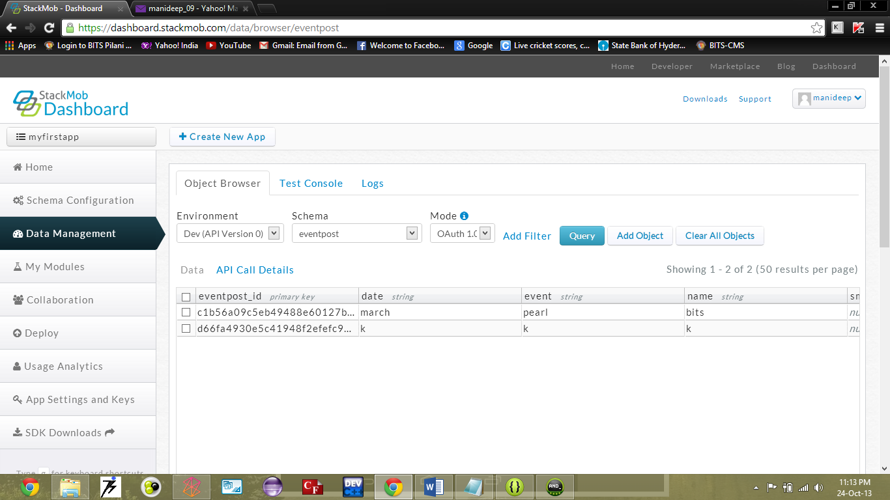

**package** com.example.myfirstapp;

**import** com.stackmob.sdk.model.StackMobModel;

**public** **class** EventPost **extends** StackMobModel {

**public** String name;

**public** String event;

**public** String date;

**public** EventPost(String name,String event,String date){

**super**(EventPost.**class**);

**this**.name=name;

**this**.event=event;

**this**.date=date;

}

**public** String getName() {

**return** name;

}

**public** **void** setName(String name) {

**this**.name = name;

}

**public** String getEvent() {

**return** event;

}

**public** **void** setEvent(String event) {

**this**.event = event;

}

**public** String getDate() {

**return** date;

}

**public** **void** setDate(String date) {

**this**.date = date;

}

}

10. **After Posting**

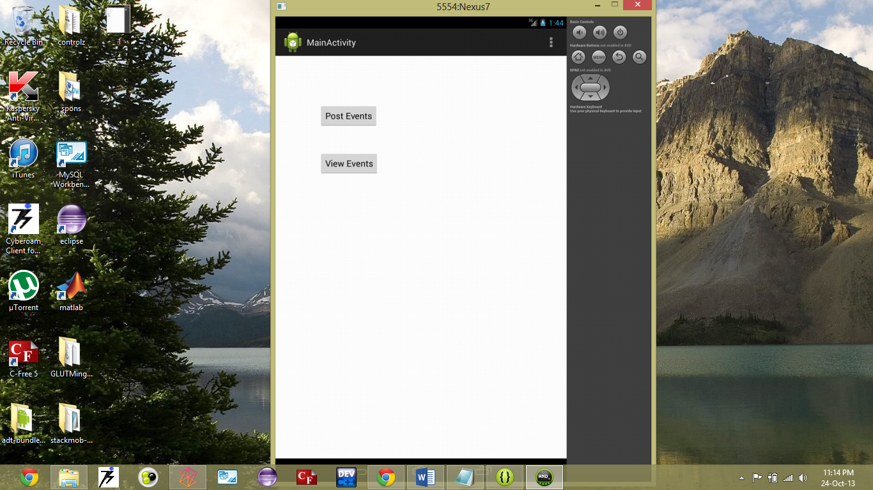

**Viewing Events**

**package** com.example.myfirstapp;

**import** java.util.Arrays;

**import** java.util.List;

**import** com.stackmob.sdk.api.StackMobOptions;

**import** com.stackmob.sdk.api.StackMobQuery;

**import** com.stackmob.sdk.callback.StackMobQueryCallback;

**import** com.stackmob.sdk.exception.StackMobException;

**import** android.os.Bundle;

**import** android.os.CountDownTimer;

**import** android.view.Gravity;

**import** android.widget.Toast;

**import** android.app.Activity;

**import** android.content.Context;

**public** **class** DisplayMessageActivity **extends** Activity {

StringBuilder s = **new** StringBuilder();

@Override

**public** **void** onCreate(Bundle savedInstanceState) {

**super**.onCreate(savedInstanceState);

EventPost.*query*(EventPost.**class**, **new** StackMobQuery().isInRange(0, 9),

StackMobOptions.*selectedFields*(Arrays.*asList*("name", "event", "date")),

**new** StackMobQueryCallback<EventPost>() {

**public** **void** success(**final** List<EventPost> result) {

// You've now got a list of the tasks

**final** Context context = getApplicationContext();

**final** **int** duration = Toast.*LENGTH_LONG*;

**for**(EventPost e : result){

s.append(e.toString());

}

**final** CharSequence text = s;

runOnUiThread(**new** Runnable() {

**public** **void** run() {

**final** Toast toast = Toast.*makeText*(context, text, duration);

toast.setGravity(Gravity.*TOP*|Gravity.*LEFT*, 0, 0);

toast.show();

**new** CountDownTimer(20000, 1000)

{

**public** **void** onTick(**long** millisUntilFinished) {toast.show();}

**public** **void** onFinish() {toast.show();}

}.start();

}

});

}

**public** **void** failure(StackMobException e) {

}

});

}

}

**TESTING**

1. **Registration module:**

* Giving random data to check if it is being sent to the database (Stackmob).
* Giving alpha-numeric values in all the fields.

1. **Login module:**

* Giving wrong username and password.
* Giving wrong username and correct password.
* Giving correct username and wrong password.
* Giving correct username and password.

1. **Posting module:**

* Giving random values in the field and check if the data is being passed in to the database (Stackmob).
* Giving alpha-numeric values in all fields and check if data is being passed.

**DEPLOYMENT**

The following are the specifications required on the mobile:

1. Android OS (any version).
2. Wi-Fi or Cellular network connectivity (internet access).
3. Server-admin logged in to Stackmob.

**REFERENCES**

1. developer.android.com
2. [www.stackmob.com](http://www.stackmob.com)
3. [www.stackoverflow.com](http://www.stackoverflow.com)
4. developer.stackmob.com